**Idea 1:**

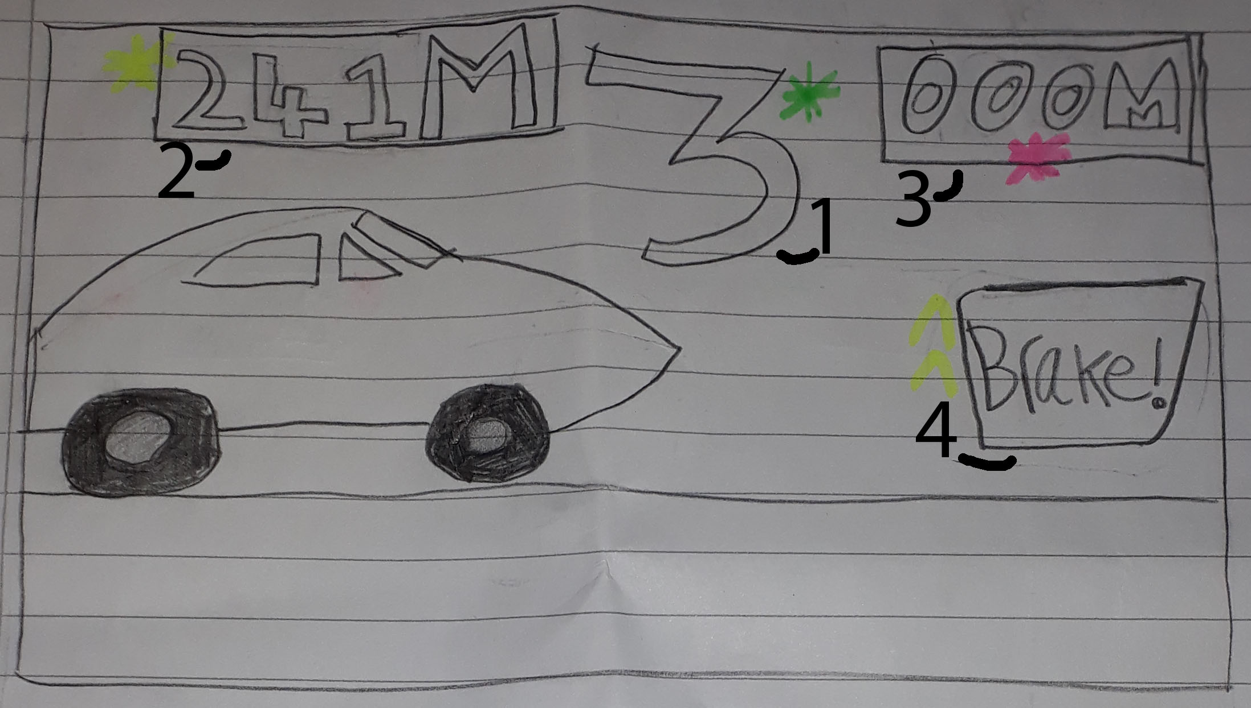

1-Countdown for when the car starts accelerating

2-The target distance the car is aiming for

3-The distance the car currently is

4-The brake pedal for when the player wants to start to slow the car down and stop

-The player has to judge when the brake pedal is pressed so the car can stop roughly at the target area

The aim is to get as close to the target distance as possible. To slow the car down, the player needs to tap the brake pedal to slow the car down. There will be an option where the first player can select the number of players playing and once the first player has got their distance, the second player has their go, then the third, etc.

**Idea 2:**

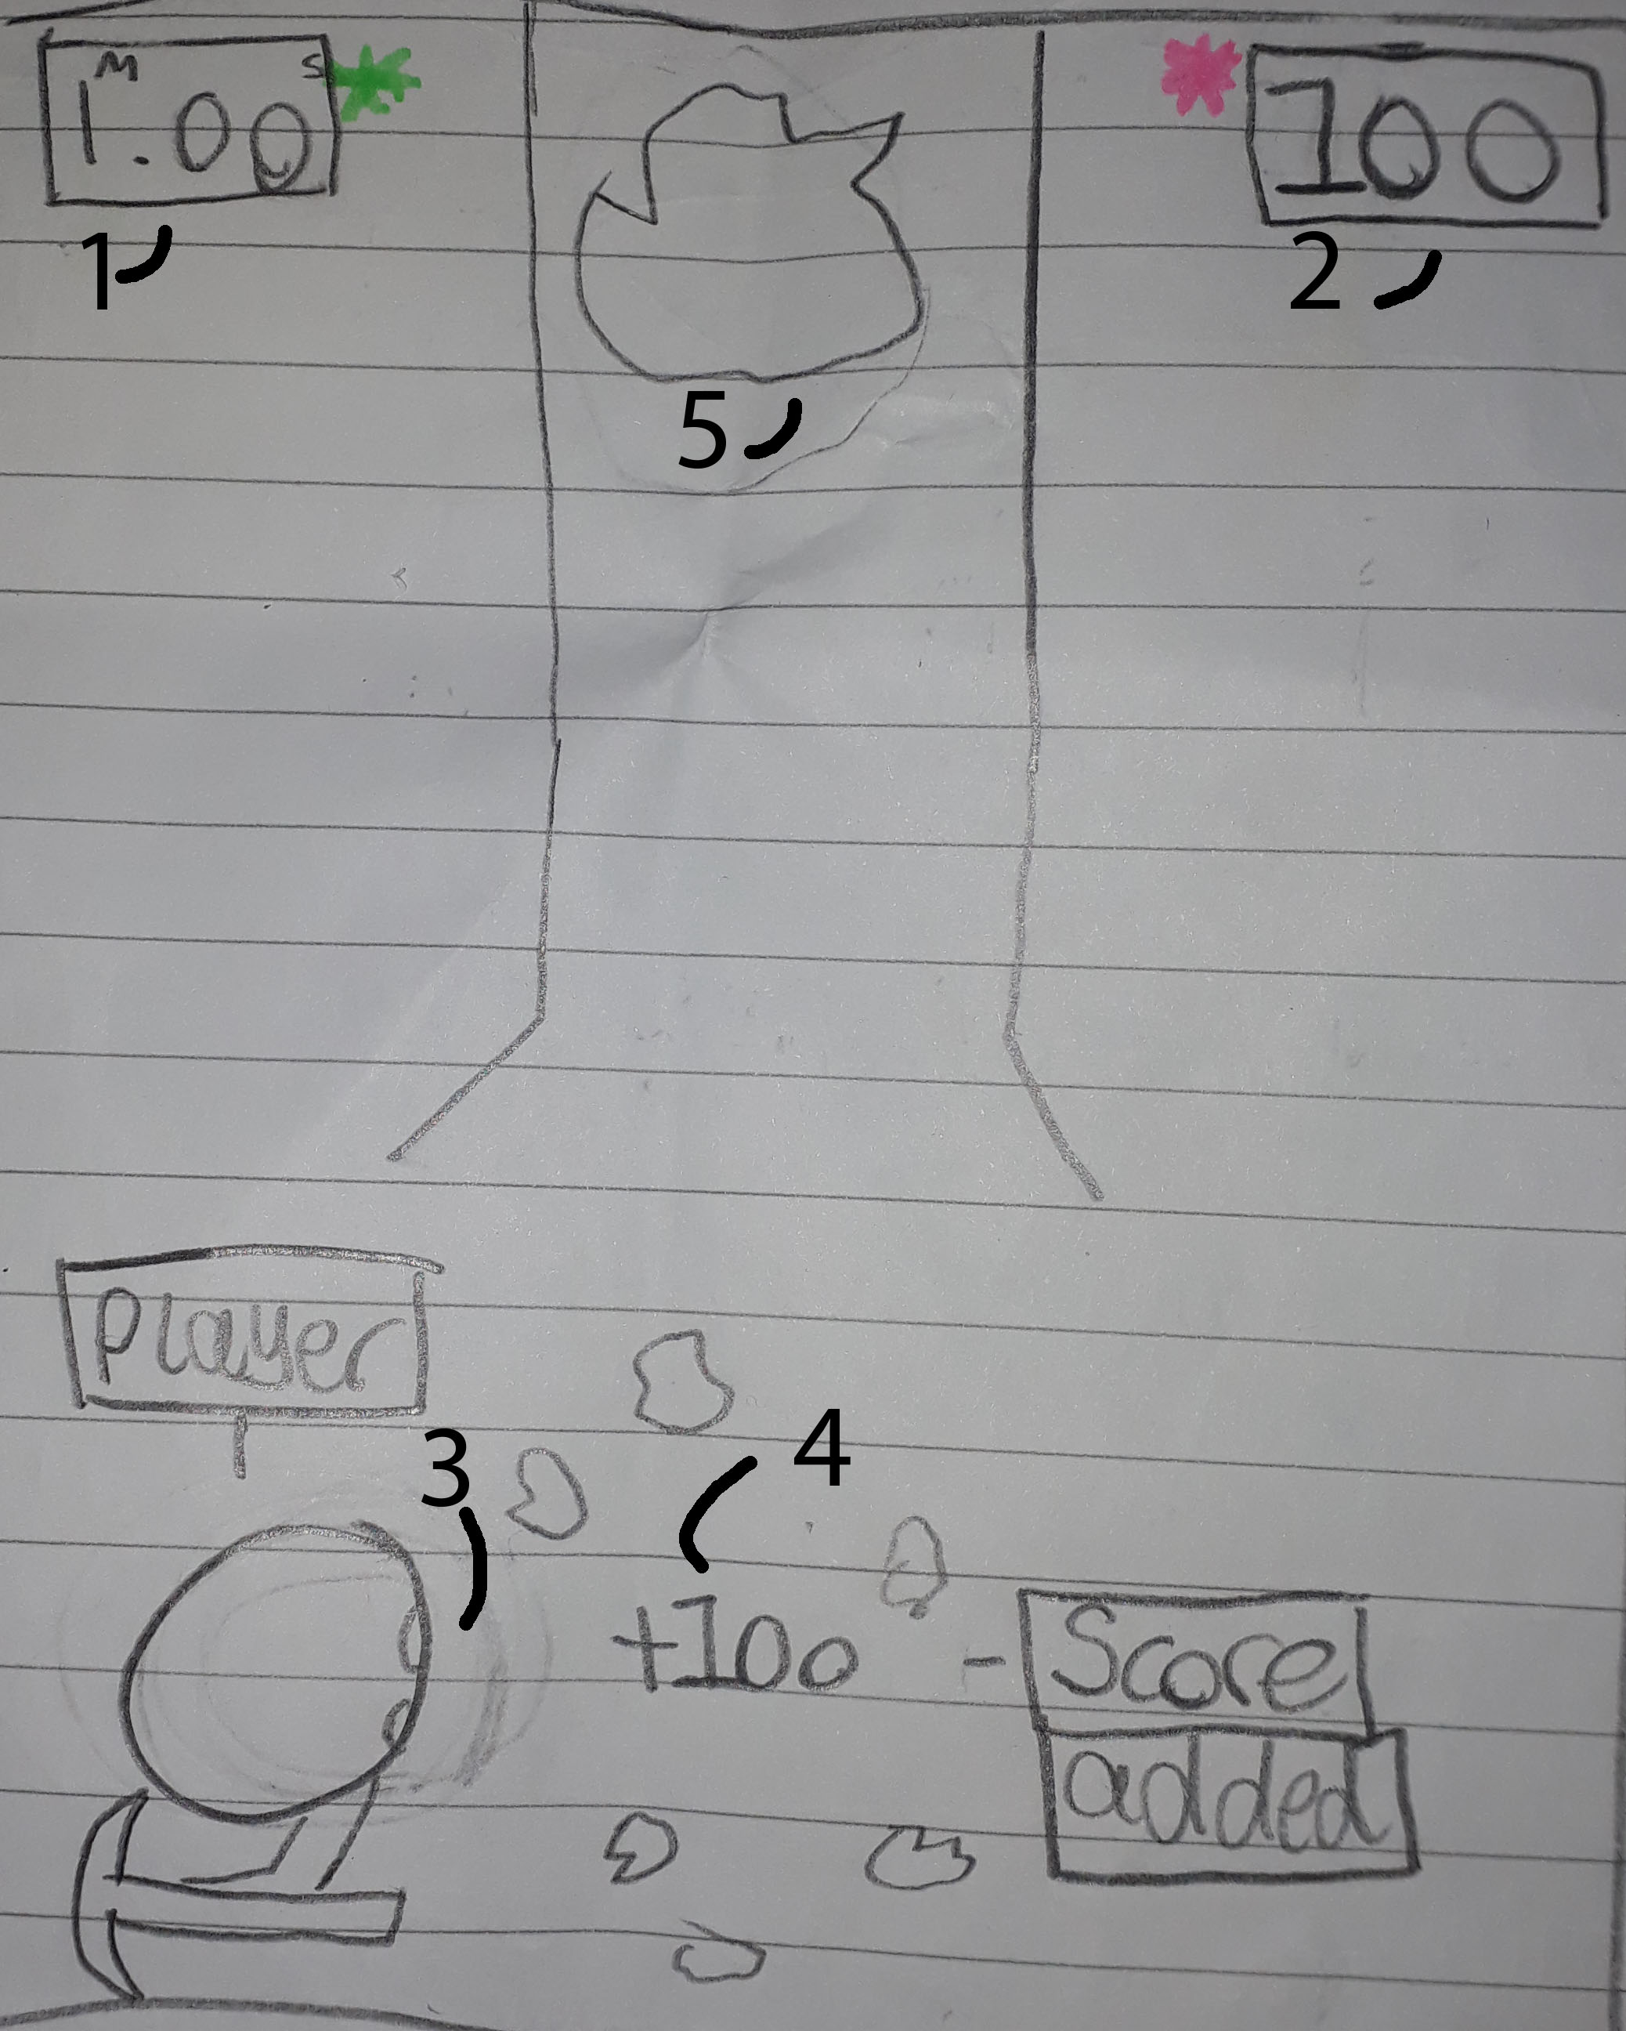

1-Timer

2-Score

3-The player

4-Score which is added to the total

5-The boulders which the player has to hit

Keeping with the idea of miners, the player has to tap when rocks, falling from the top of the screen, are in front of the miner. Depending on when the player taps the screen, either bronze, silver or gold appears depending on when the player taps the screen and the likewise when the score is added: Bronze is 10, Silver is 50 and Gold is 100. The player may also have a minute and may be tweaked during building of the game. The winner is the player with the highest score.

**Idea 3:**

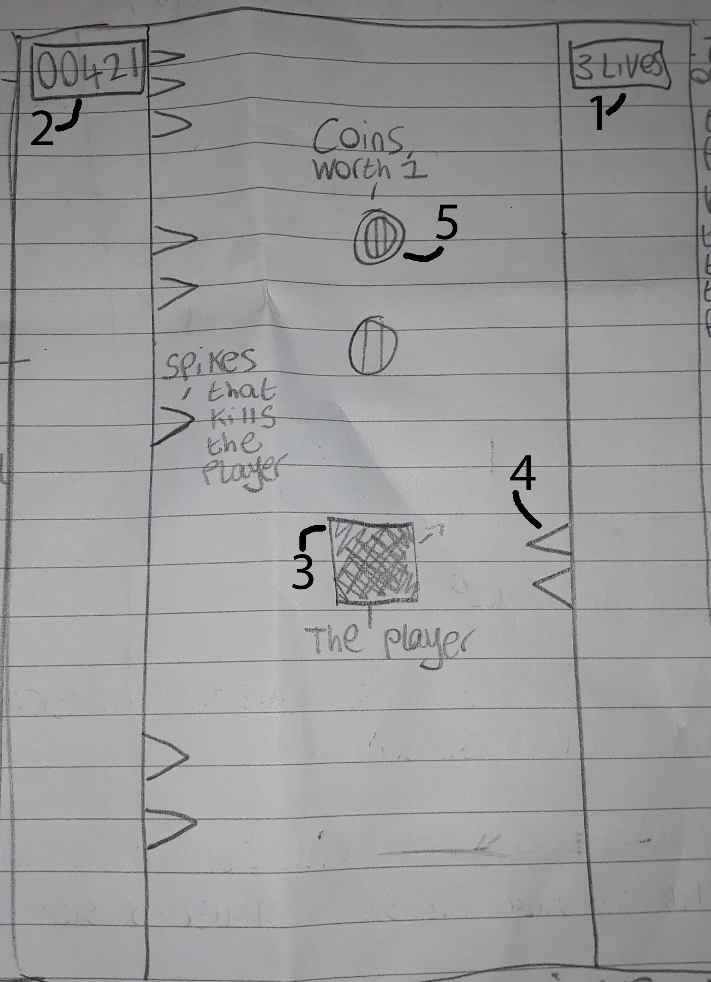

1-Life counter

2-Score Counter

3-Player controlled block

4-Spikes

5-Collectable coins

The player has to tap the screen to change the side on which the square is on.

The player that survived the longest and goes the furthest distance wins

Increase of difficulty by speeding up the rate in the spawning of spikes and decreasing the space between the walls. The speed increase will also increase the score rate

The player also has 3 lives before giving it to the next player

The player can collect coins to unlock aesthetic changes to the block, background etc.